Martha Pendergast
Real Estate

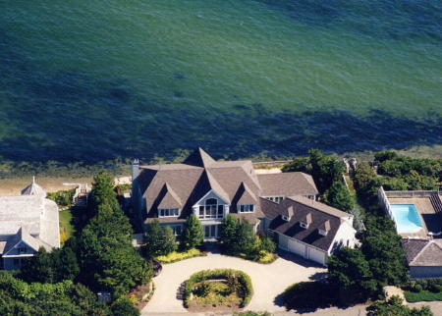

Seaside spectacular. Stunning, panoramic views of Nantucket Sound adorn this custom Contemporary home built in 1997 with impeccable design and detail. Open floor plan includes: gourmet kitchen, formal dining room, library, den, screened porch, family room, three bedroom suites including master with fireplace, wardrobe room and private deck with unparalleled views of the sea. Private beach, bluestone patio and expansive deck complete this exquisite home near championship golf course.
Offered at……………..…....$8,000,000

“TRITON WAY OCEANFRONT
NEW SEABURY”
Phone 508-548-4040 MLS
E-mail: pendergast @capecod.net

